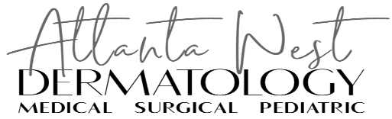

By signing this form, you acknowledge that Atlanta West Dermatology & Surgery Center performs certain services that require the use of an outside laboratory. These services include but are not limited to skin biopsy, surgery, blood draws and cultures. The different laboratories we use are:

Quest
LabCorp
Finan Dermatopathology
Diagnostic Dermatology Associates (DDA)
DermTech
DermStat

If you have a preference between Quest or LabCorp please circle to indicate your preference.

We are not able to quote you pricing for the services provided by these outside labs nor can we assist in any way with their bills. We do have lists they have provided us with the insurances they accept. If you would like to view them, please let a member of our staff know.

_____________________________ ______________________________ _________
Print Name of Patient Signature Date

